VIVA-2

Create any Mountain Range with Snowfall over it using GIMP

1. STEP 1 : Add the respective Picture and Add layer to it.
2. STEP 2 : Add FG colour to it.
3. STEP 3 : Add Noise from filters 1. Filters > Noise > HSV noise 2. Make dulling and Value full
4. STEP 4 : Add Blur Filter 1. Filter > Blur > Gaussian Blur 2. Make X and Y as 1
5. STEP 5 : Colours > levels
6. STEP 6 : Adjust the levels
7. STEP 7 : Change the Normal mode to Screen
8. STEP 8 : Snowfall will appear on the Image.

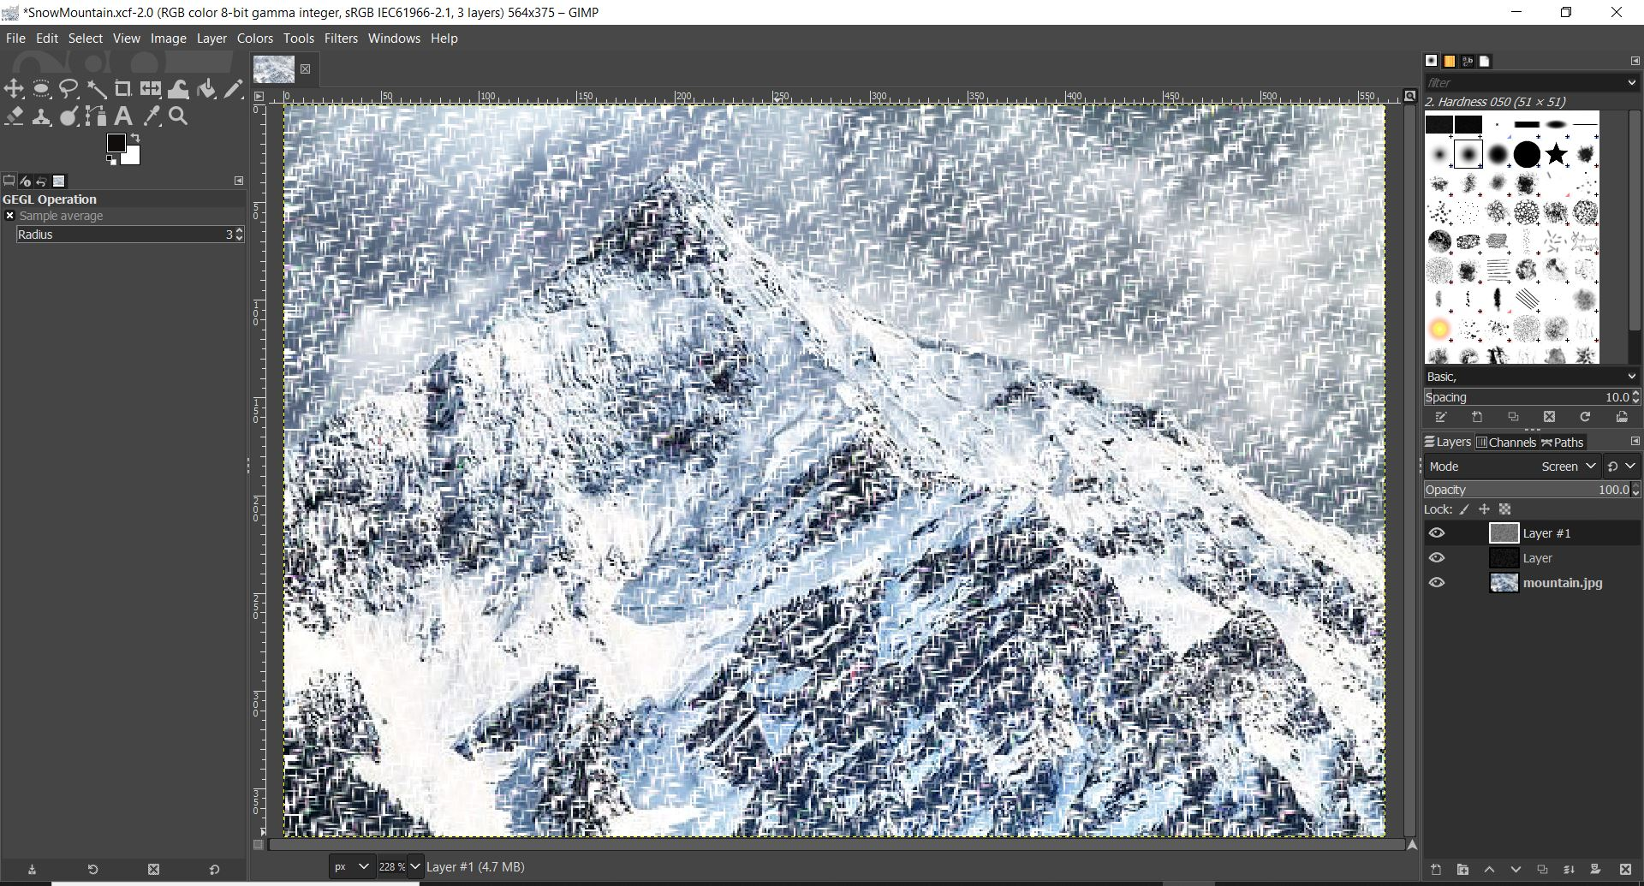

2. Create any City or Skyscraper using Blender

* Open new file
* Delete contents of the file
* Insert a new cube
* Scale and extrude it to create a platform which will act as the base for the building
* Select the upper faces and extrude it to appropriate length
* Repeat above step to create multiple floors
* Now for the rooftop, press I and hold inwards followed by extruding to give it a feel of boundary
* Press Ctrl+R to place loop cuts for creating windows
* Then press I
* Repeat Steps 8 and 9 where you want to place windows
* Now Create material with required colours and assign it to required face.
* Save the fileand render the final model.
* Finish

